Search on search in box Secpol.msc or open command promote and type secpol.msc

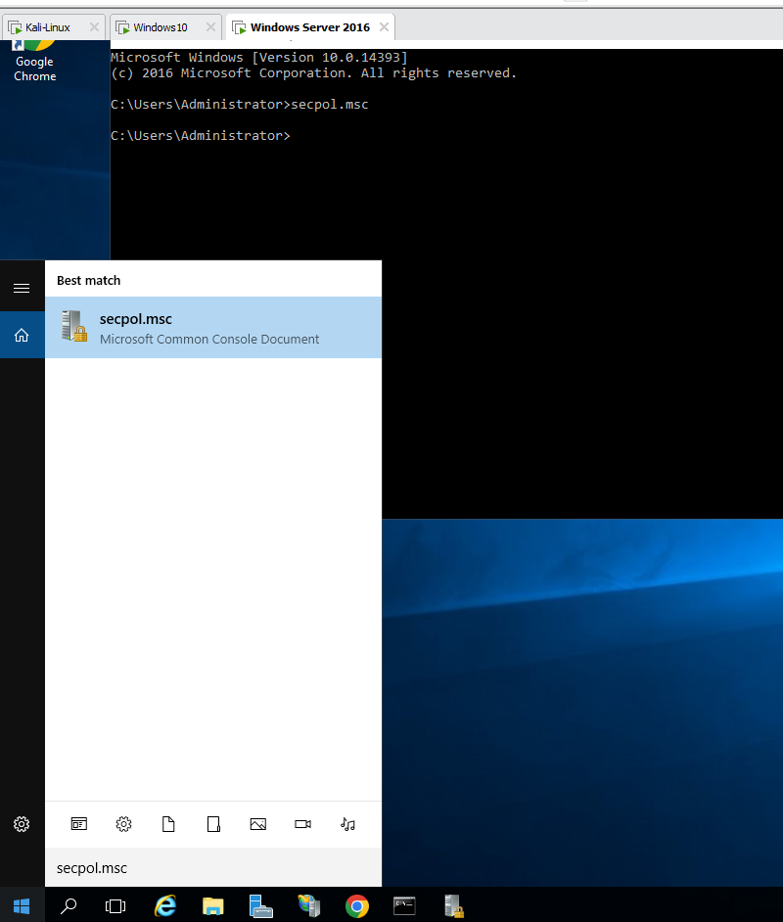

2)Click on IP Security

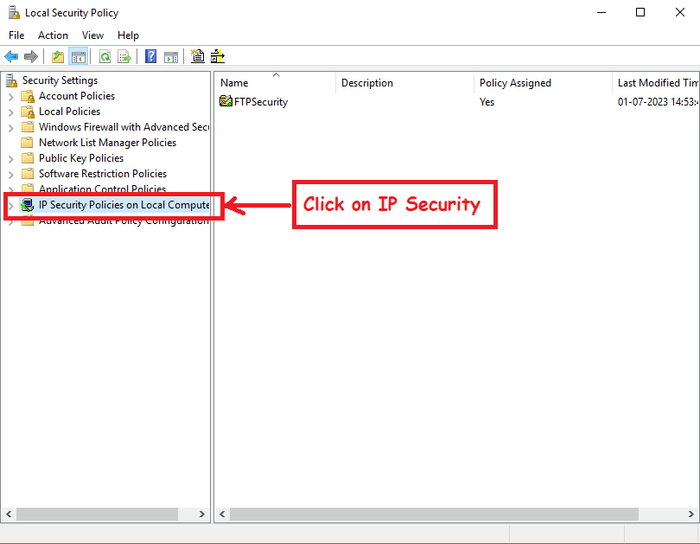

3)Right Click and Create IP Security Policy

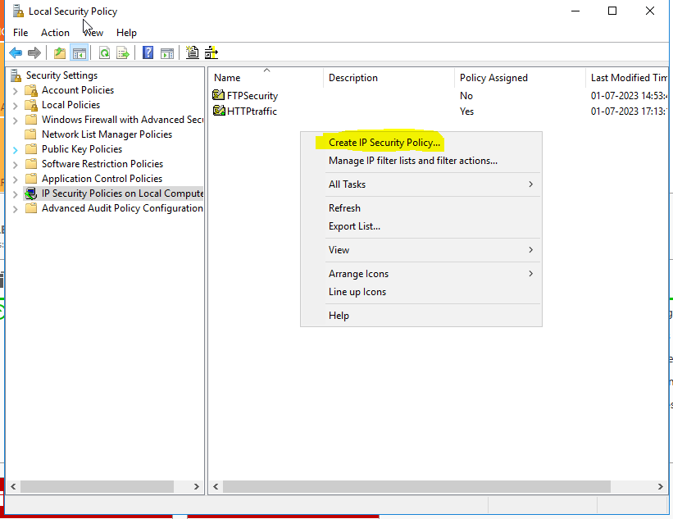

4) Then click Next

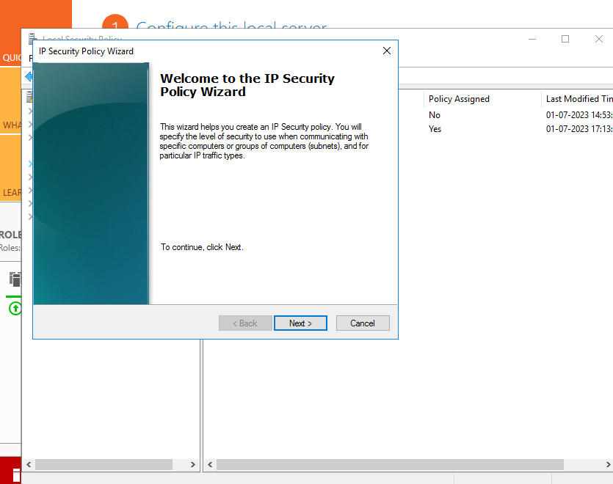

5)After that click next and write policy name.

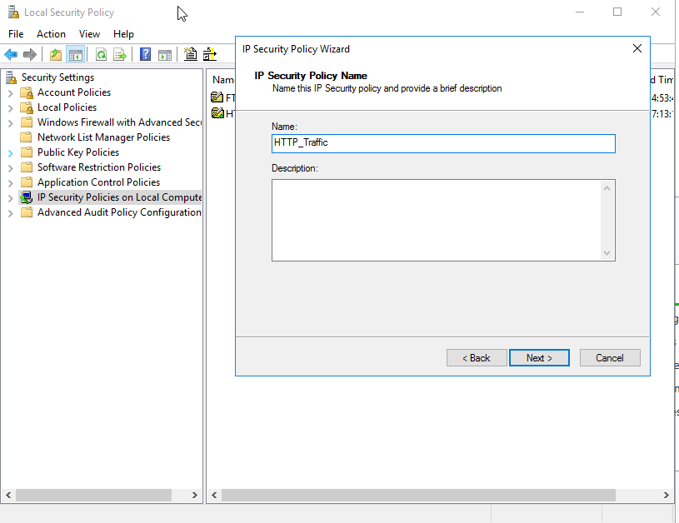

6)Then click next.

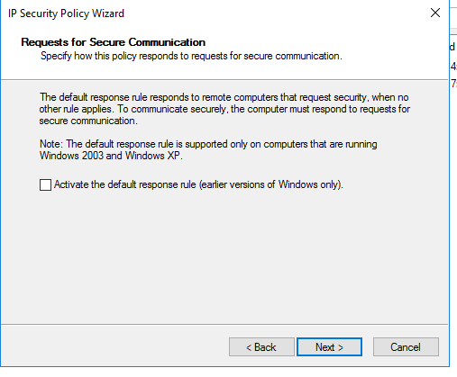

7) then next and Finish.

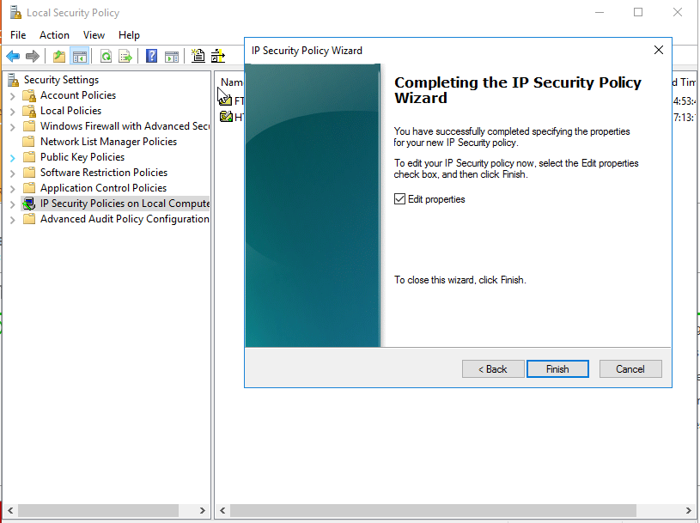

8)after finish showing new window.

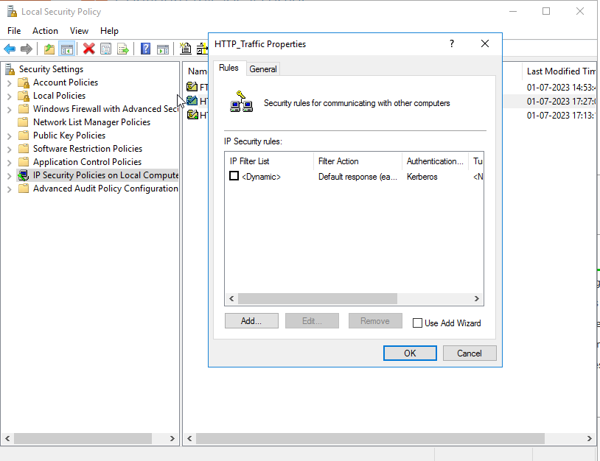

9)Then Click on add button.

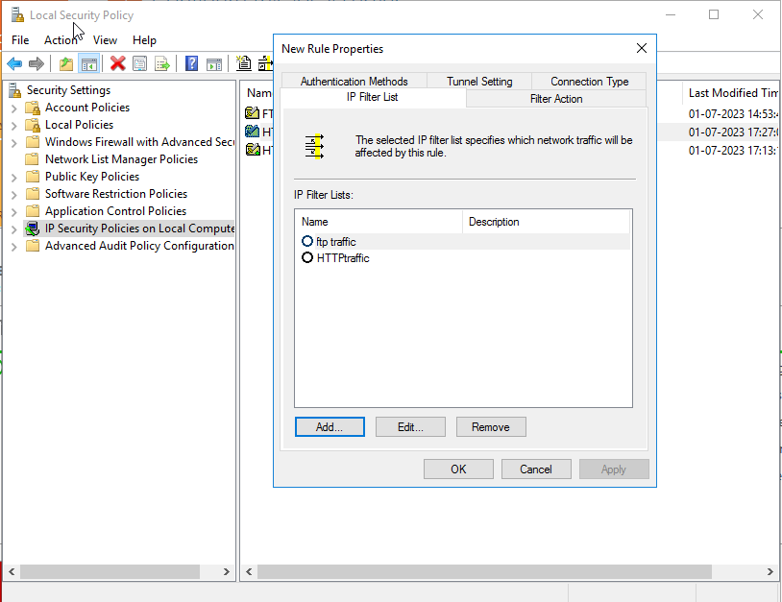

10)Again click on Add button.



11)Then again click add and write the IP Filter List Name and OK.

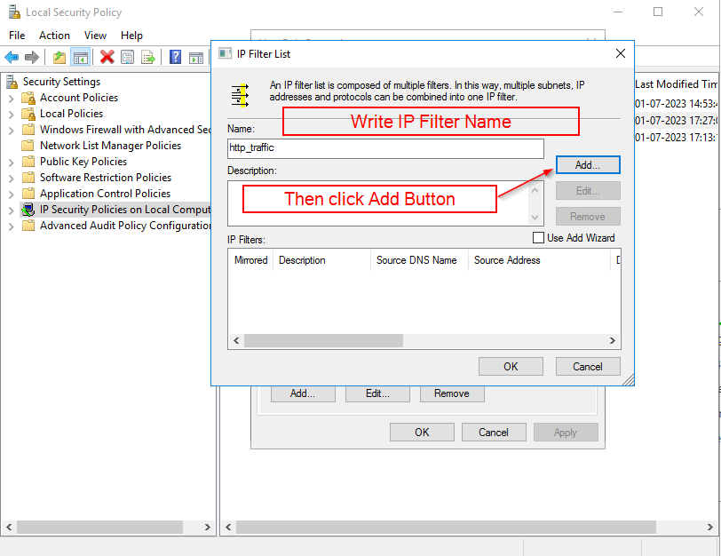

12) After that Select address.

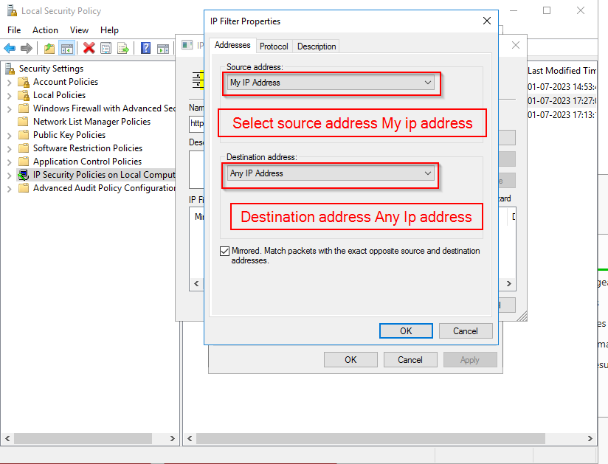

13) Click on Protocol select TCP protocol

Then From this Port put 8000 which is added website port.

And then OK.

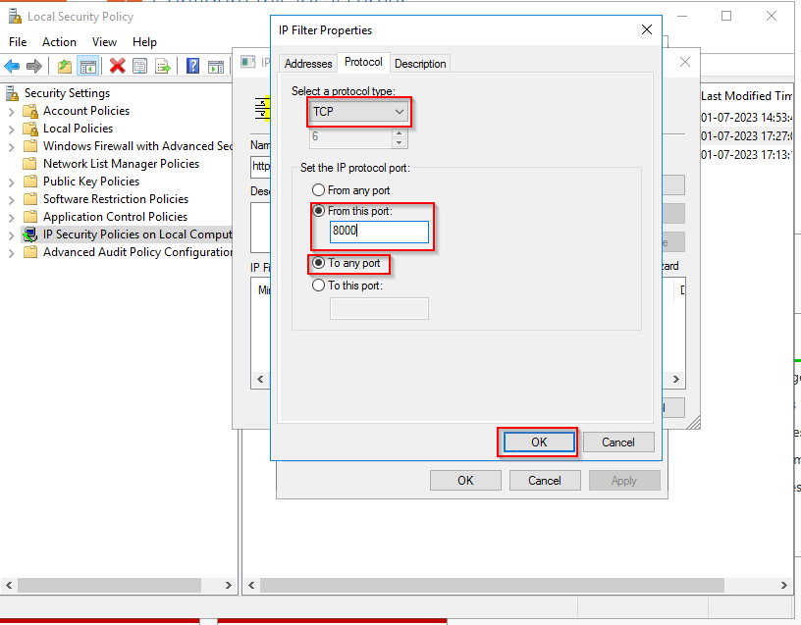

14) Then click OK.

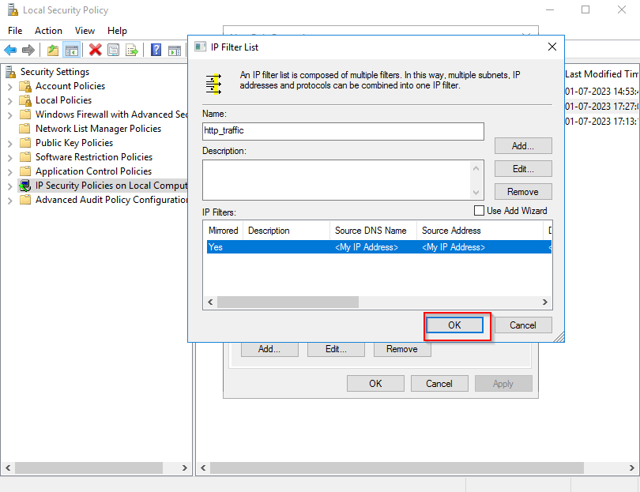

15) Then Select our HTTP_taffic rule, then select Filter Action.

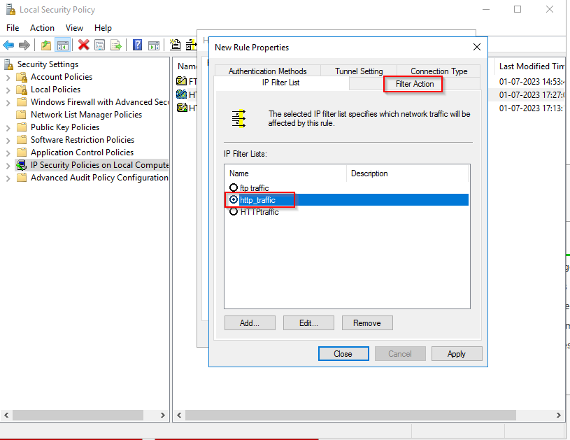

16) After selecting Filter Action Click on Add button.

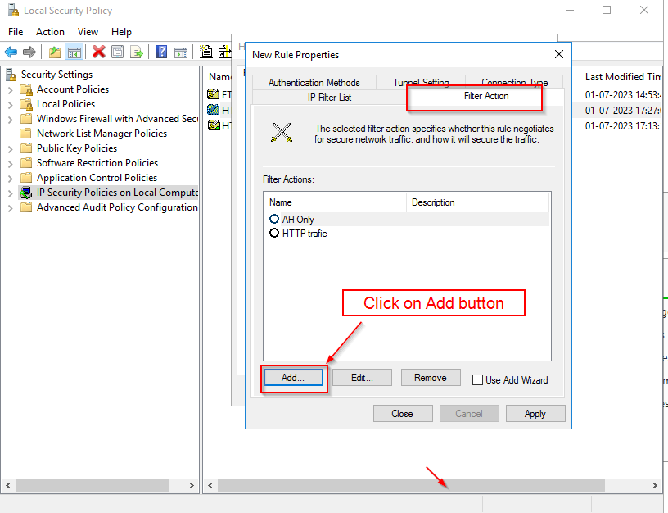

17) Select Integrity and encryption and click OK.

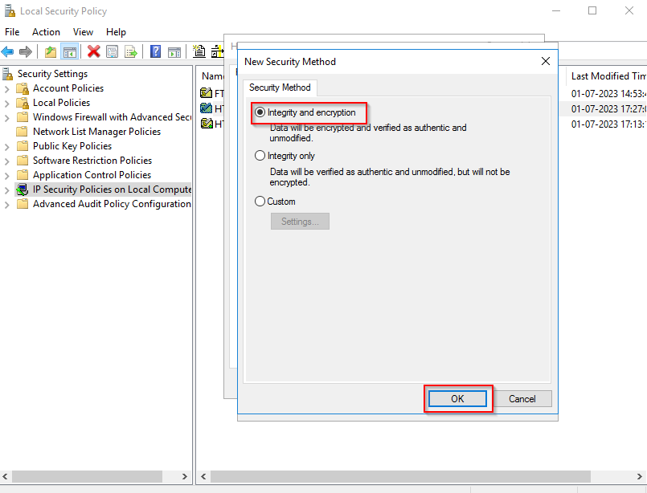

18)

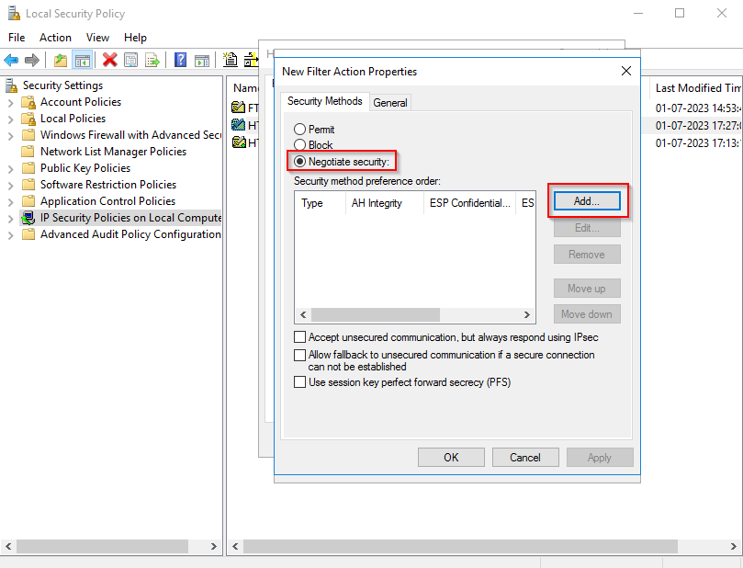

19) Then click ok

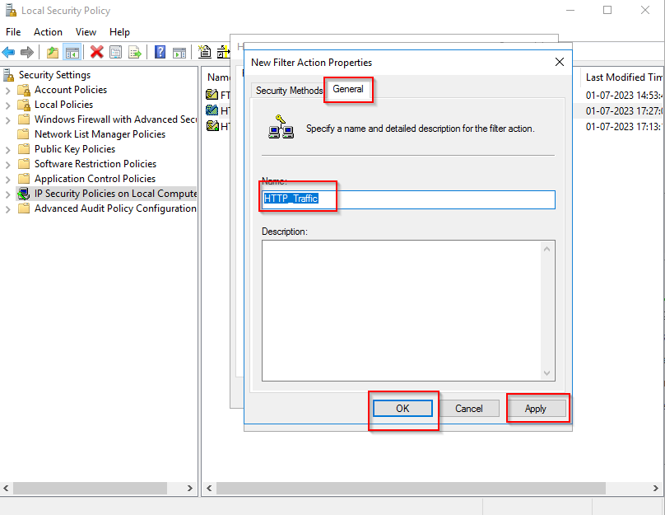

20) Then select HTTP_Traffic Rule then Authentication Methods

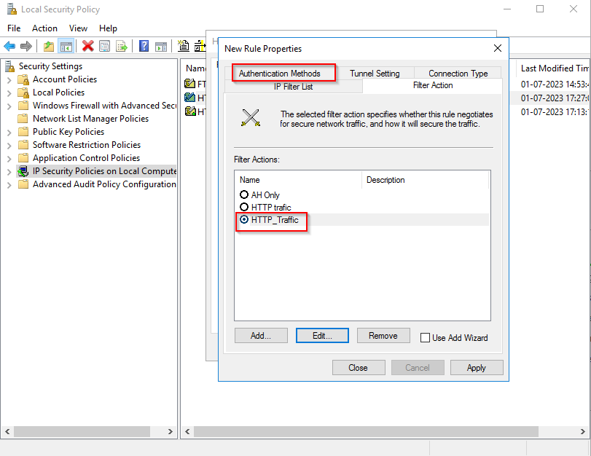

21) After Clicking Authentication methods click Add button.

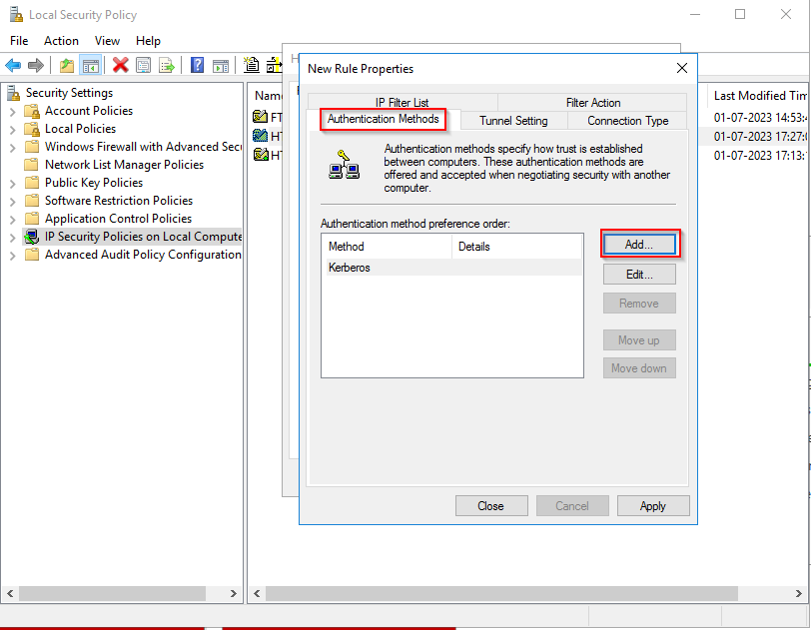

22) Then Select Use this string

And put manual password

Example:- Admin@123

Then Select key and click OK.

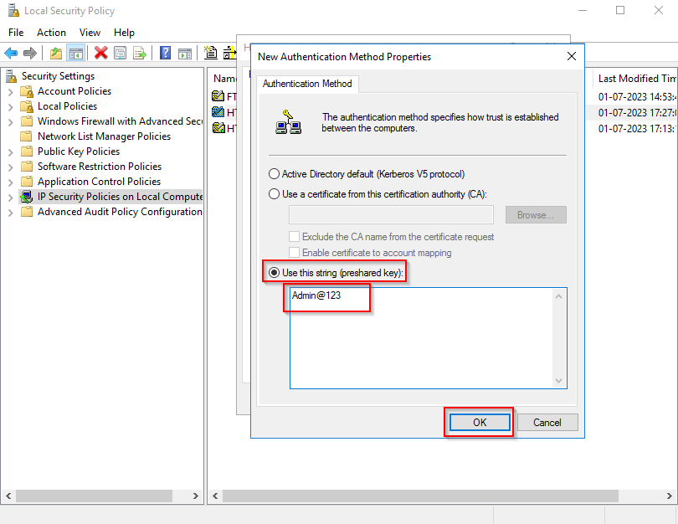

Note:- Server Side Configuration done

***********************Client side Configuration********************************

1. Search on secpol.msc.

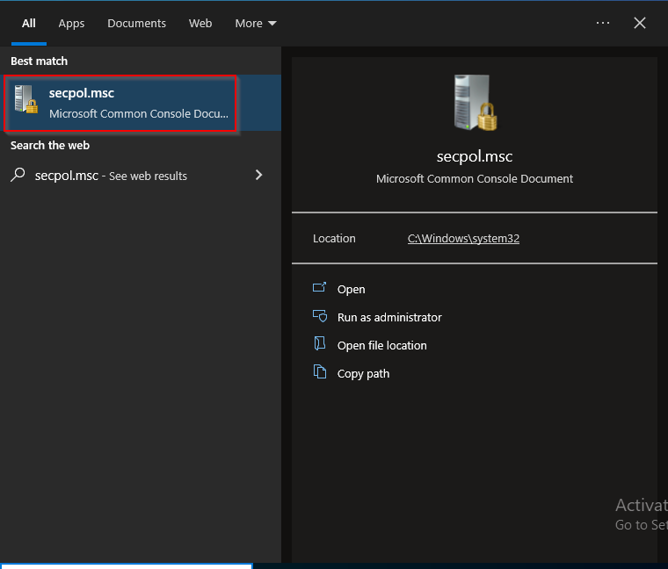

2)

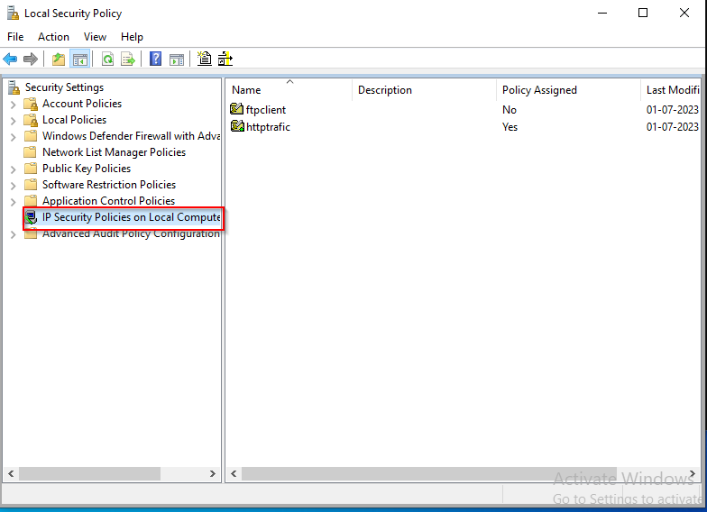

3)

